**Exp-2-DATA MANIPULATIONS**

**1)Consider a table employees and Execute the following statement**

**“Create the following tables with the given structure.”**

**EMPLOYEES TABLE**

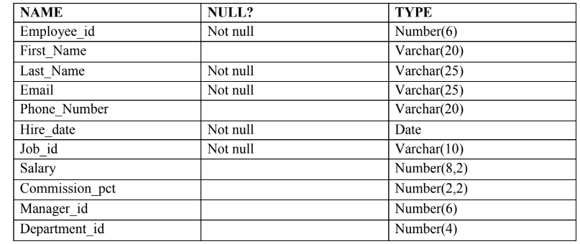

**Ans: create table employees(employee_id number(6) not null,first_name varchar(20),last_name varchar(25) not null,email varchar(25) not null,phone_number varchar(20),hire_date date not null,job_id varchar(10) not null,salary number(8,2),commission_pct number(2,2),manager_id number(6),department_id number(4));**

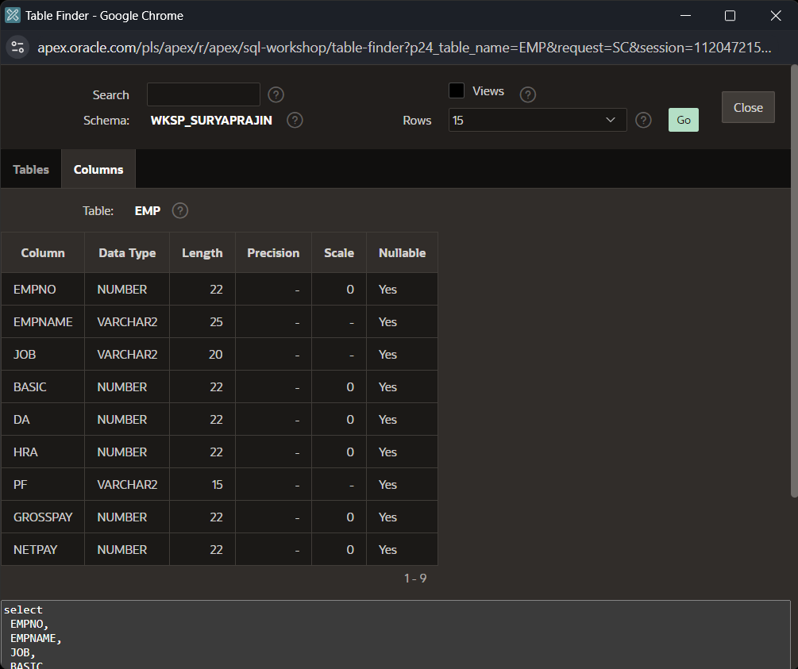

(a) Find out the employee id, names, salaries of all the employees

Ans: select employee_id,first_name,last_name,salary from employees;

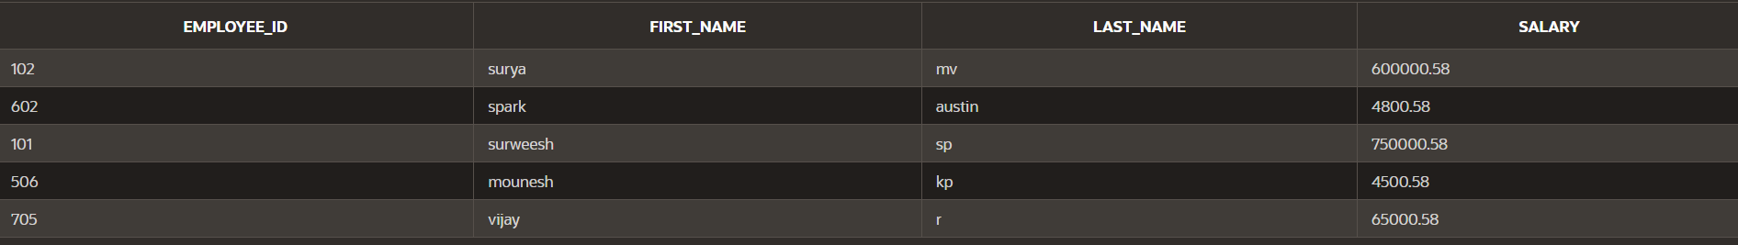

(b) List out the employees who works under manager 100

Ans:select* from employees where manager_id=100;



(c) Find the names of the employees who have a salary greater than or equal to 4800

Ans:select first_name,last_name from employees where salary>=4800;



(d) List out the employees whose last name is ̳AUSTIN‘

Ans:select * from employees where last_name like 'austin';



(e) Find the names of the employees who works in departments 60,70 and 80

Ans:select first_name,last_name from employees where department_id in(60,70,80);



(f ) Display the unique Manager_Id.

Ans:select distinct manager_id from employees;

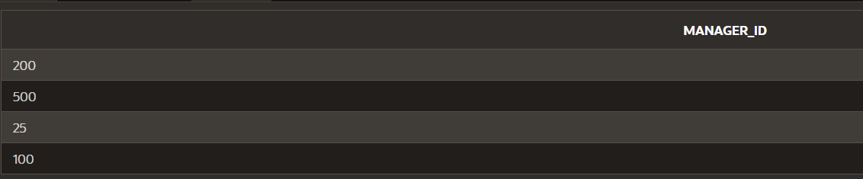

2)Create an Emp table with the following fields:

(EmpNo, EmpName, Job,Basic, DA, HRA,PF,

GrossPay, NetPay) (Calculate DA as 30% of Basic and HRA as 40% of Basic)

Ans: create table emp(empno int,empname varchar(25),job varchar(20),basic int,da int,hra int,pf varchar(15),grosspay int,netpay int);

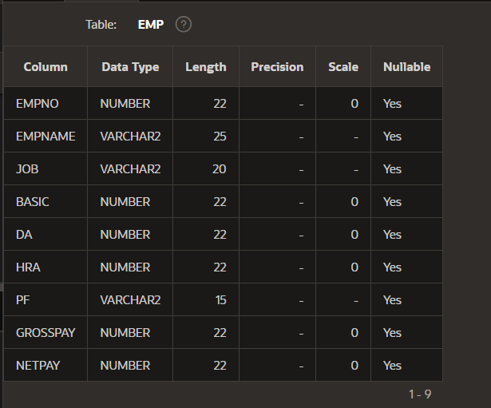

(a) Insert Five Records and calculate GrossPay and NetPay.

**Ans:**insert into emp values(101,'surya','manager',150000,0,0,0,0,0);

insert into emp values(102,'surweesh','developer',75000,0,0,0,0,0);

insert into emp values(103,'suryamv','lead_coder',100000,0,0,0,0,0);

insert into emp values(104,'vijay','developer',65000,0,0,0,0,0);

insert into emp values(105,'vasanth','hr',200000,0,0,0,0,0);

update emp set da=basic*0.3,hra=basic*0.4,pf=basic*0.05,grosspay=basic+da+hra,netpay=grosspay-pf where empno=101;

update emp set da=basic*0.3,hra=basic*0.4,pf=basic*0.05,grosspay=basic+da+hra,netpay=grosspay-pf where empno=102;

update emp set da=basic*0.3,hra=basic*0.4,pf=basic*0.05,grosspay=basic+da+hra,netpay=grosspay-pf where empno=103;

update emp set da=basic*0.3,hra=basic*0.4,pf=basic*0.05,grosspay=basic+da+hra,netpay=grosspay-pf where empno=104;

update emp set da=basic*0.3,hra=basic*0.4,pf=basic*0.05,grosspay=basic+da+hra,netpay=grosspay-pf where empno=105;

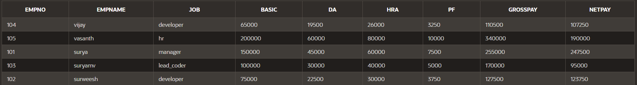

(b) Display the employees whose Basic is lowest in each department.

Ans:select * from emp where basic in (select min(basic)as basic from emp group by job);

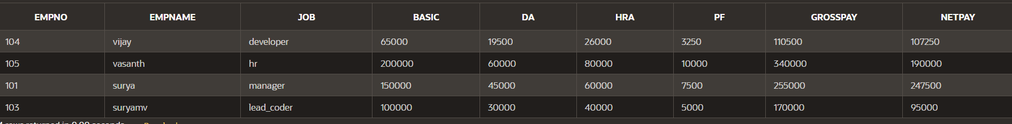

(c) If Net Pay is less than 150000

Ans:select * from emp where netpay<150000;

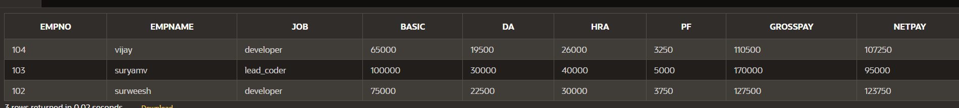

3.1) Create the DEPT table based on the DEPARTMENT following the table instance chart

Below.

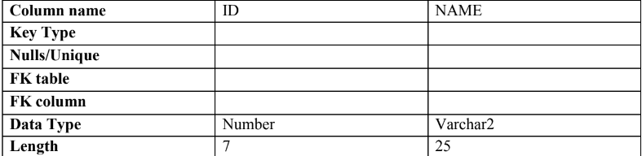

Ans:create table dept(id number(7),name varchar2(25));

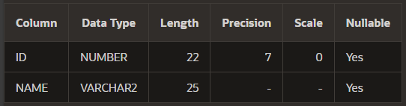

2. Create the EMP table based on the following instance chart. Confirm that the table is

Created.

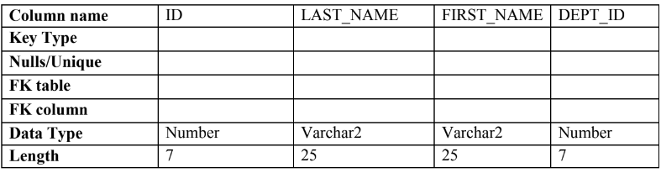

Ans:create table emp1(id number(7),last_name varchar2(25),first_name varchar2(25),dept_id number(7));

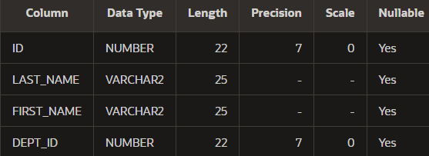

3 Modify the EMP table to allow for longer employee last names. Confirm the

modification.(Hint: Increase the size to 50)

Ans:alter table emp1 modify last_name varchar2(50);

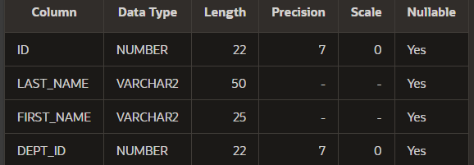

4 Create the EMPLOYEES2 table based on the structure of EMPLOYEES table. Include

Only the Employee_id, First_name, Last_name, Salary and Dept_id coloumns. Name the

columns Id, First_name, Last_name, salary and Dept_id respectively.

Ans:create table employees2 (id number(2),first_name varchar2(25),last_name varchar2(25),salary number(8,2),dept_id number(4));

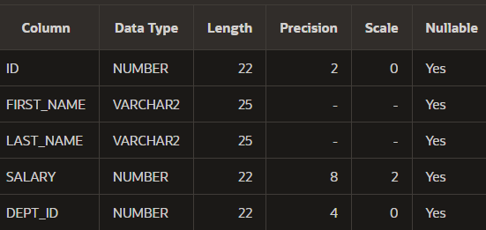

5 Drop the EMP table.

Ans:drop table emp1;



6 Rename the EMPLOYEES2 table as EMP.

Ans:alter table employees2 rename to emp1;



7 Add a comment on DEPT and EMP tables. Confirm the modification by describing the

Table.

Ans:comment on table dept is 'information of employee department';

comment on table emp1 is 'information of employee details';



8 Drop the First_name column from the EMP table and confirm it.

Ans:alter table emp1 drop column first_name;



